First non-repeating character

DESCRIPTION:
Write a function named first_non_repeating_letter that takes a string input, and returns the first character that is not repeated anywhere in the string.
For example, if given the input 'stress', the function should return 't', since the letter t only occurs once in the string, and occurs first in the string.
As an added challenge, upper- and lowercase letters are considered the same character, but the function should return the correct case for the initial letter. For example, the input 'sTreSS' should return 'T'.
If a string contains all repeating characters, it should return an empty string ("") or None -- see sample tests.

SOLUTION:
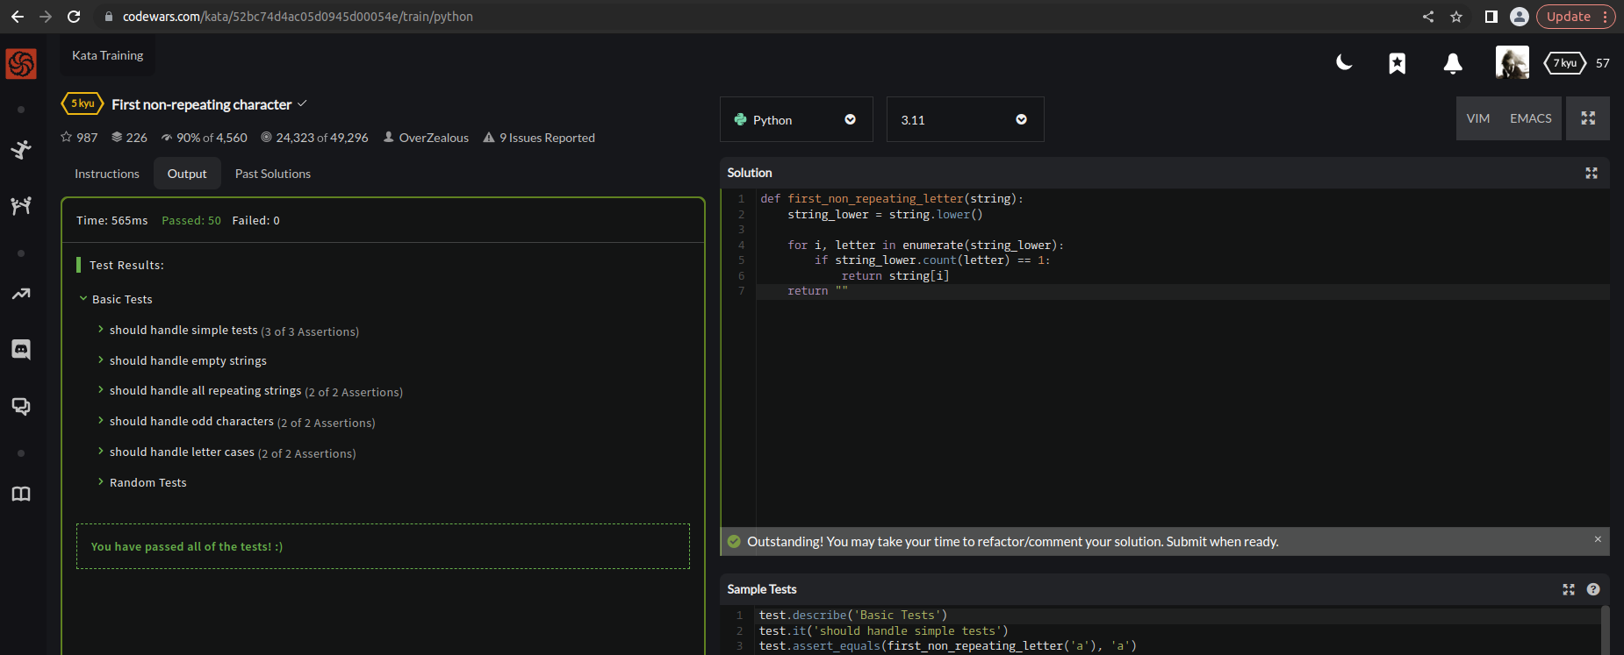

EXPLANATION:
The function first converts the input string to lowercase and stores it in a new variable called string_lower. This allows the function to perform a case-insensitive search for non-repeating letters. Next, the function iterates through the characters of the input string using the enumerate() function to keep track of the index of each character. For each character, the function checks if its count in the lower cased string is equal to 1 using the count() method. If the count is 1, it means that the character is not repeated, so the function returns the original (case-sensitive) character from the input string using the return statement. If there are no non-repeating letters in the string, the function returns an empty string using the return "" statement.

